Stage 5 – Port Authority
COURSE DESIGNER: John Royer (Outdoor Dynamics)
SCORING: Comstock 32 rounds.
TARGETS: 9 cardboard targets, 5 steel targets
SCORED HITS: 2 Best hits per carboard will be scored.

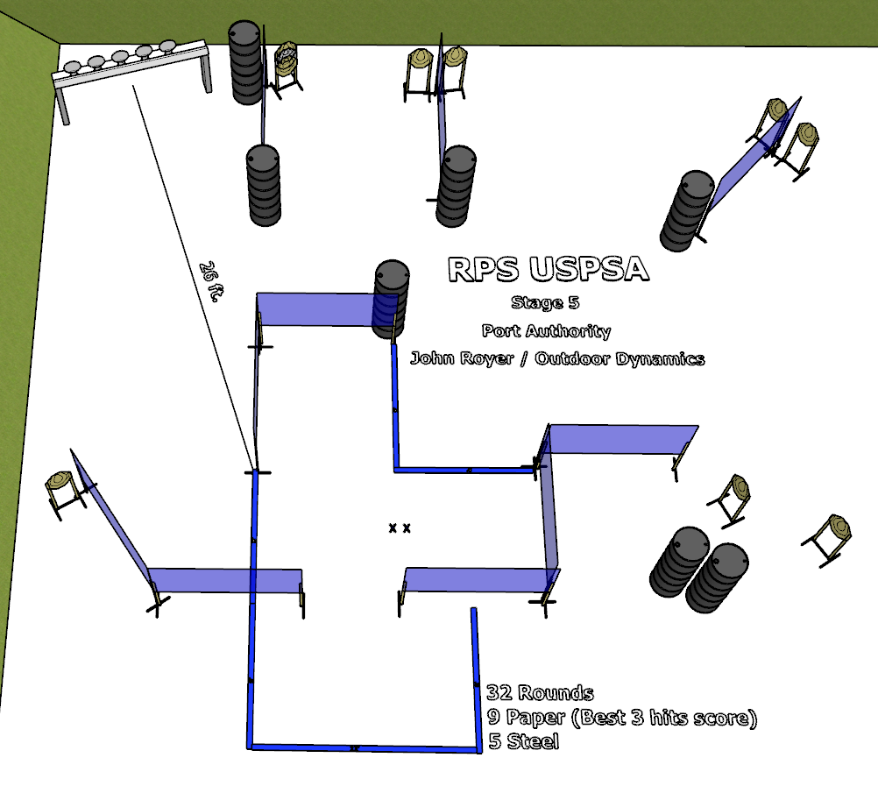

Written Stage Briefing:

Stage 5 – Port Authority - is a 32 round, 160 point, Comstock Course. There are 9 cardboard targets and 5 steel targets.

The best 3 hits paper will be scored.

Starting both feet on Shooting Sports Innovations Xs.
Handgun is loaded and holstered, wrists below belt.
PCC is loaded held in both hands, stock on belt.

On the audible start signal, engage targets from within the shooting area.

USPSA / NROI Range Commands:
- Make Ready
- Are you ready?
- Standby
- If finished, unload and show clear
- If clear, hammer down and holster (Handgun)
If clear, hammer down and flag (PCC)
If clear, cylinder closed and holster (Revolver)
- Range is clear

Setup Notes:
12 Single Wall Stands
4 Double Wall Stands
10 Full Wall
8 Target stands / 16 target sticks
1 Plate Rack
3 Steel Challenge Plates and Stands
14+ barrels
1 Start Xs


